**USER GUIDE FOR CHITETEZO AIR POLLUTION MONITORING SYSTEM**

**Table of Contents**

1. Introduction 2

2. System Overview 2

3. System Components 2

3.1. Hardware Components 3

3.2. Software Components 7

4. Installation 8

4.1. Choose a suitable location 8

4.2. Mount the sensors 8

4.3. Connect the components 8

4.4. Power up the system 9

5. System Operation 9

5.1. Power on the system 9

5.2. Real-time Data Collection and Storage 9

5.3. Data display and visualization 9

5.4. Alerts and notifications 9

6. Data Analysis 9

6.1. Access raw data 9

6.2. Analyse data 10

6.3. Compare data 10

6.4. Generate reports 10

7. Maintenance and Troubleshooting 10

7.1. Regular maintenance 10

7.2. Sensor calibration 10

7.3. Troubleshooting 10

7.4. Firmware and software update 11

8. Safety Precautions 11

8.1. Electric Safety 11

8.2. Installation and Mounting 11

8.3. Sensor Handling 12

8.4. Maintenance 12

8.5. Data Retrieval and Communication 13

8.6. Emergency Situations 13

8.7. Compliance with Local Regulations 13

9. Technical Support 13

9.1. Troubleshooting Guide 13

9.2. Contact Technical Support 13

10. Contact Information 14

10.1. Email 14

10.2. 14

# 

# Introduction

* Thank you for choosing our Air Pollution Monitoring System. This user guide will provide you with all the necessary information to set up and effectively use the system. Please read the following instructions carefully.

# System Overview

* The Chitetezo Air Pollution Monitoring System is designed to measure and monitor the level of air quality. It detects various pollutants in the air, including but not limited to Carbon monoxide (CO), Carbon dioxide (CO₂), Ozone, Volatile organic compounds (VOC), Smoke, Alcohol, and Nitrogen, and calculates the level of air quality. The system provides real-time data collection and analysis, helping you make informed decisions about your environment.

# System Components

* The Chitetezo Air Pollution Monitoring System consists of the following components:

## Hardware Components

* Gas sensors(MQ2 and MQ135): These are used for detecting and measuring air quality and various gases in the atmosphere.

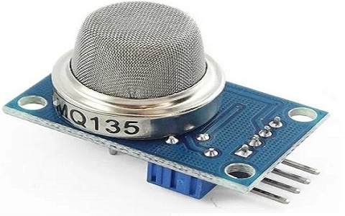

**Figure 1** MQ-135 Gas Sensor

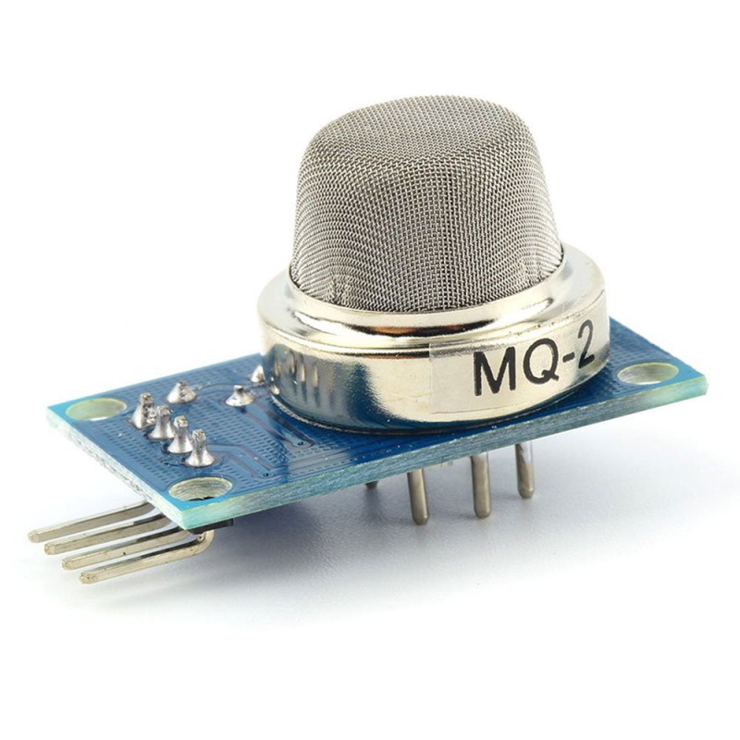

**Figure 2** MQ-2 Gas Sensor

* DHT22 Sensor: This sensor is used for measuring temperature and humidity.

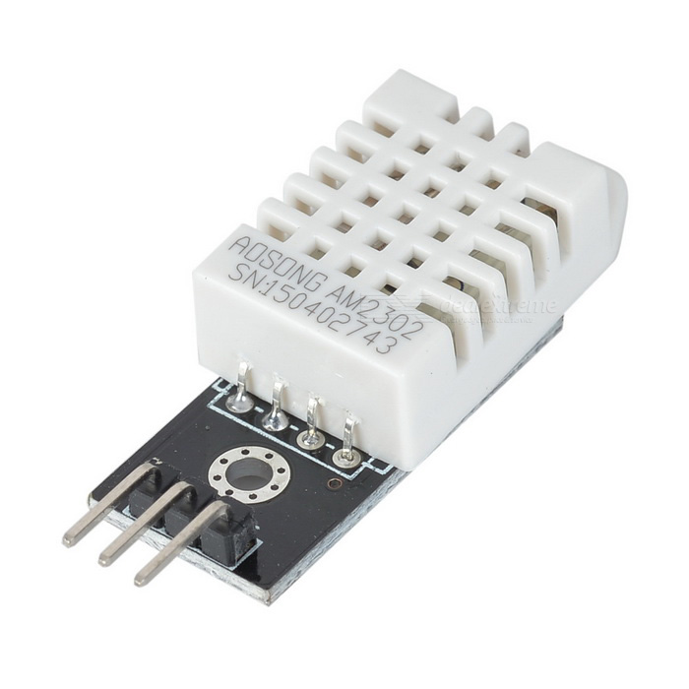

**Figure 3** DHT22 Sensor

* ADC(ADS1115): This is an analog-to-digital converter (ADC) integrated circuit that provides precise and high-resolution analog-to-digital conversion capabilities.

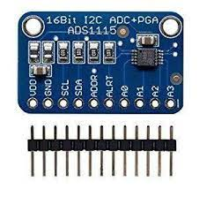

**Figure 4**: ADS1115

* Raspberry Pi 3: This is a microcontroller that receives real-time data from the Gas sensor(MQ135) , Humidity, and Temperature sensor, processes it, and sends it to the database both Firebase and MySQL for storage and further analysis.

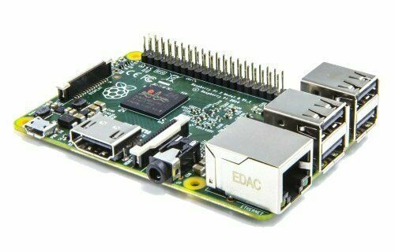

**Figure 5** Raspberry Pi

* The LCD 16x2 with I2C (Inter-Integrated Circuit) is a popular display module that combines a 16-character by 2-line alphanumeric LCD (Liquid Crystal Display) with an I2C interface. The I2C interface simplifies the connection and control of the LCD, reducing the number of wires required for communication.

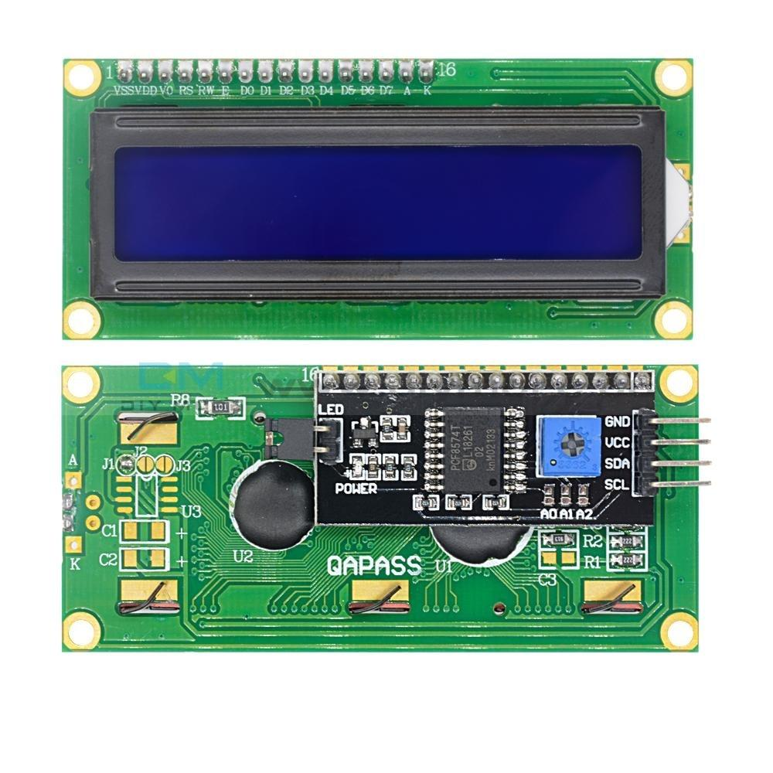

**Figure 6:** LCD 16x2 with I2C

* LEDs(Light-Emitting Diodes): These devices light up when certain thresholds are reached;

1. Green LED lights up when the value of air quality is between 0-50
2. Yellow LED lights up when the value of air quality is between 51-100
3. Red LED lights up when the value of air quality is above 100

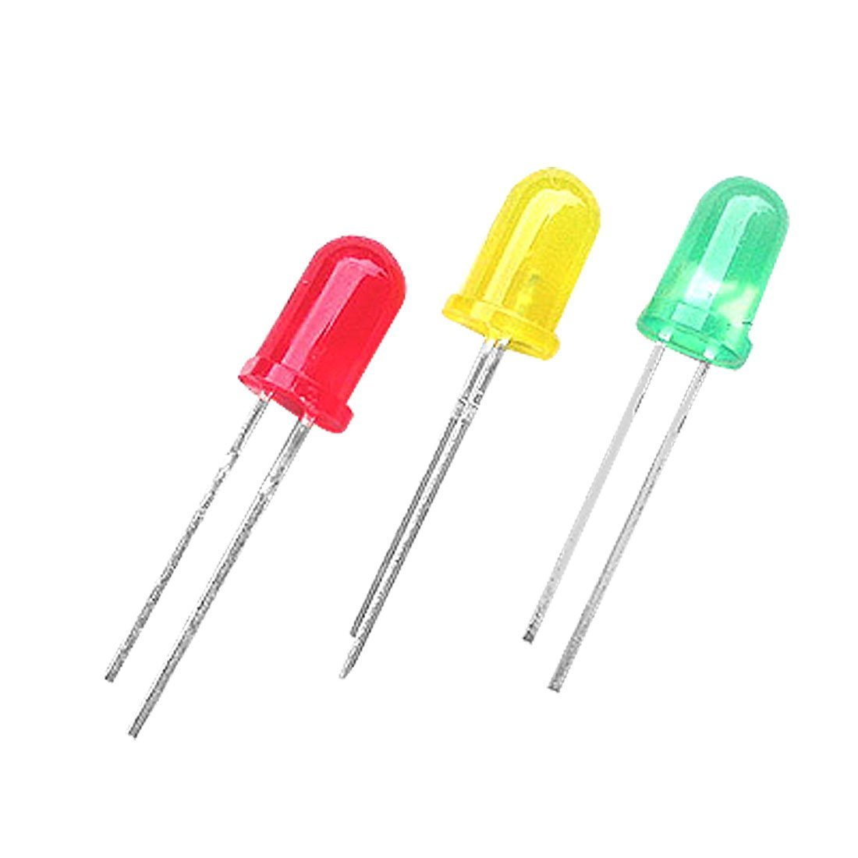

**Figure 7** LEDs

* Buzzer: This device produces a buzzing sound when the value of air quality is above 100

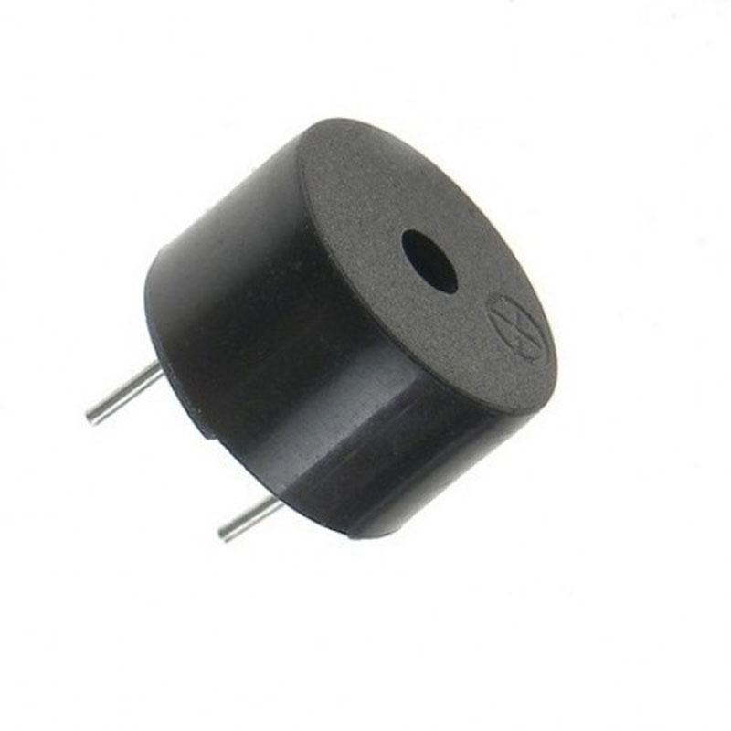

**Figure 8** Buzzer

* Power supply: The system requires a 5V stable power source for operation.

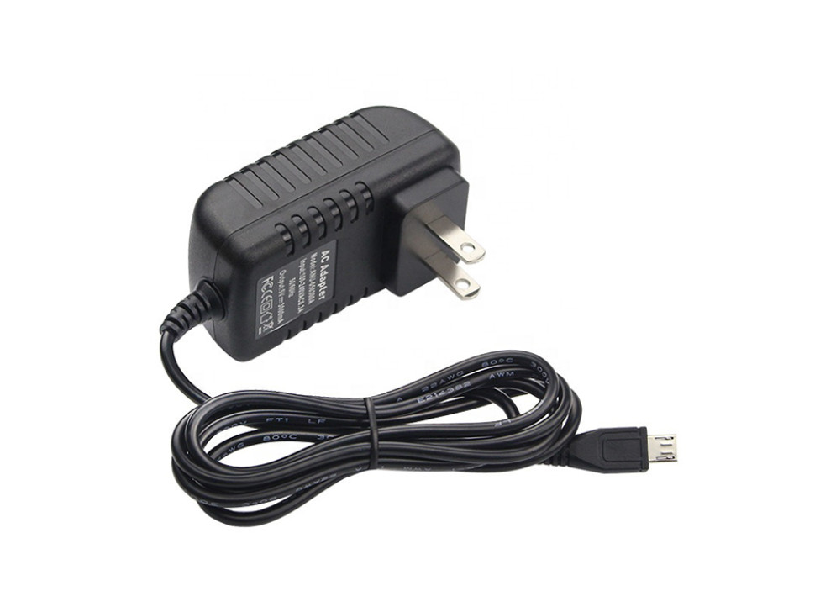

**Figure 9** Power supply

## Software Components

* ThingSpeak: This is an online cloud platform that visualizes air quality data.
* Chitetezo Dashboard: This is where the users can access the air quality data in a friendly format.
* Chitetezo Mobile app: This application allows users to monitor air quality remotely by receiving the air quality data values and notifications if the values are above 100.
* Database Management System: This is where the air quality data is stored for further data analysis.

# Installation

* The Chitetezo air pollution monitoring system is designed for indoor use. Make sure that the location of the monitor is free of obstructions so that the sensors can get a clear reading of the air quality. To install the system, follow these steps:

## Choose a suitable location

* The location of the air quality monitor is essential, as it will affect the accuracy of the readings. Select a site representative of the area you want to monitor, away from direct sources of pollution. It could be in an office, a classroom, or even your living room.

## Mount the sensors

* Install the air pollution sensors according to the provided instructions, ensuring proper orientation and alignment. It is important to ensure that the sensors are properly oriented and aligned so that they can accurately measure the air quality.

## Connect the components

* The sensors, a display unit (LCD), and a communication module should be connected following the provided wiring diagram. It is important to make sure that all of the connections are secure so that the system can operate properly.

## Power up the system

* Once all of the components are connected, the system can be powered up. It is important to ensure that the power source is stable so that the system does not experience any power outages.

# System Operation

* To operate the Chitetezo air pollution monitoring system, follow these steps.

## Power on the system

* Turn on the power supply and ensure that all components function correctly.

## Real-time Data Collection and Storage

* The data recorder(database) will collect and store data from the sensors for further analysis and storage.

## Data display and visualization

* Data is retrieved from the system and displayed on Liquid Crystal Display (LCD), Chitetezo Mobile application, Chitetezo Dashboard, and ThingSpeak.

## Alerts and notifications

* Notifications are sent to the mobile application.

# Data Analysis

## Access raw data

* The system accesses the data collected by the sensors or external devices.

## Analyse data

* The system analyses the pollutant concentrations and trends over time to assess air quality.

## Compare data

* The system compares the collected data with local air quality standards or guidelines to evaluate compliance.

## Generate reports

* The system generates reports or visualizations to communicate air quality information effectively. These reports can be used by government agencies, businesses, or individuals to make decisions about air quality.

.

# Maintenance and Troubleshooting

## Regular maintenance

* The sensors should be cleaned regularly to remove dust and dirt that can interfere with their readings. The sensors should also be checked for any physical damage, such as cracks or broken wires.

## Sensor calibration

* The sensors should be calibrated at recommended intervals to ensure that they are providing accurate readings.

## Troubleshooting

* If the system is not working properly, the troubleshooting guide can be used to identify and fix the problem. The troubleshooting guide includes a list of common problems and solutions.

## Firmware and software update

* Stay up to date with the latest firmware or software releases to ensure optimal performance.

# Safety Precautions

* Follow the safety guidelines provided during installation, operation, and maintenance

## Electric Safety

* Avoid exposing the system or its components to water or other liquids.
* Only use a 5V power supply.
* Do not touch electrical connections or components with wet hands
* If you notice any damage to the power supply or wiring, immediately disconnect the system and contact technical support.
* Consider environmental factors such as wind, rain, and extreme temperatures when choosing the installation site.
* Disconnect the power supply before performing any maintenance on the system.

## Installation and Mounting

* Follow the manufacturer's guidelines for installation and mounting.
* Ensure that the system is mounted securely and placed in a stable location to prevent accidental falls or damage.
* Consider environmental factors such as wind, rain, and extreme temperatures when choosing the installation site.
* Take necessary precautions to prevent unauthorized access or tampering with the system.

## Sensor Handling

* Handle the air pollution sensors with care to avoid damage or misalignment.
* Do not touch or obstruct the sensor surfaces to maintain accurate readings.
* Clean the sensors as per the manufacturer's instructions and use appropriate cleaning materials to prevent contamination.

## Maintenance

* Perform regular maintenance and inspection of the system components as recommended by the manufacturer.
* Follow the calibration schedule provided by the manufacturer to ensure accurate measurements.
* Keep the system clean and free from dust or debris that may interfere with the sensor's performance.
* Adhere to any specific maintenance procedures or safety precautions outlined in the user manual.

## Data Retrieval and Communication

* The system includes communication modules and data transfer capabilities, please ensure that network connections are secure and protected.

## Emergency Situations

* In the event of a malfunction, abnormal readings, or any other safety concerns, immediately power off the system and disconnect the power supply.
* Contact technical support or follow the manufacturer's instructions for troubleshooting and resolution of issues.

## Compliance with Local Regulations

* Familiarize yourself with local regulations and guidelines for the operation and installation of this Chitetezo air pollution monitoring system.

# Technical Support

## Troubleshooting Guide

* Refer to the troubleshooting section in the user guide provided with your system. It will contain a list of common issues and possible solutions. Follow the step-by-step instructions to identify and resolve the problem.

## Gather Information

* Before reaching out to technical support, gather relevant information about the issue you are experiencing. Includes:
  + **System Details**: Note down the model and serial number of your Air Pollution Monitoring System. This information will help the support team understand the specific configuration of your system.
  + **Description of the Issue:** Provide a detailed description of the problem you are facing. Include any error messages displayed, unusual behavior, or specific steps that led to the issue.
  + **Environment Details:** If applicable, provide information about the installation environment, such as temperature, humidity, power supply stability, and any other relevant factors that may impact system performance.

## Contact Technical Support

* Reach out to technical support using the contact information gathered provided in the document. Choose the preferred method of communication, whether it is via phone or email.
  + **Phone Support**: If phone support is available, call the provided support number. Be prepared to provide the system details and a clear description of the issue. Follow the instructions provided by the support representative to troubleshoot and resolve the problem.
  + **Email Support**: If email support is available, send a message to the provided support email address. Include all the gathered information from step 3, such as system details and a detailed description of the issue. Attach any relevant screenshots or error logs, if applicable.

## Follow-Up and Resolution

* Once you have contacted technical support, follow their instructions for troubleshooting and resolving the issue. Be responsive to any requests for additional information or clarification. If the problem persists, continue to work with the technical support team until a satisfactory resolution is achieved.

# Contact Information

## Email

* [bsc-com-ne-12-18@unima.ac.mw](mailto:bsc-com-ne-12-18@unima.ac.mw)
* [bsc-com-ne-13-18@unima.ac.mw](mailto:bsc-com-ne-12-18@unima.ac.mw)
* [bsc-com-ne-09-18@unima.ac.mw](mailto:bsc-com-ne-12-18@unima.ac.mw)
* [bsc-com-ne-03-18@unima.ac.mw](mailto:bsc-com-ne-12-18@unima.ac.mw)

## Phone Numbers

* +265882791514
* +265888797616
* +265998648466
* +265992823997